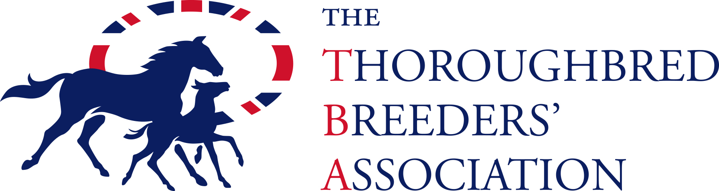

RACECOURSE BADGE SCHEME FOR BREEDERS (RBSB) APPLICATION FORM
ALL INDIVIDUAL MEMBERS OF THE RACECOURSE BADGE SCHEME FOR BREEDERS (RBSB} MUST HAVE A PHOTO CARD. Please send a passport-sized photo with this application form with your name printed on the reverse.

Required fields*
1 | *TBA Membership No (this can be found on the TBA website when you log in)
2 | *Email Address
3 | *Full Name:
4 | *Contact Phone Number:
5 | * Would you like to receive entry and declaration alerts by:  - Email  - SMS  by not ticking the box we will assume you do not wish to receive these alerts
6 | *Address (including postcode):
7 | *Registered Breeding Address (if different from above):
8 | *Please detail all individual registered breeding names whether they be sole (please list all variations  for sole names), joint or name of stud. e.g. variations of sole names: ‘Mr A Smith’ and/or ‘Mr Andrew Smith’ and/or ‘Mr Andrew J Smith’ joint name:‘Mr A Smith and Mrs P Jones’ and/or ‘Mr A Smith and The TBA Stud’ stud name: ‘The TBA Stud’. Future breeding stock linked by these names will automatically be updated however should you breed under a different name please inform the TBA.
9 | *Please detail any registered names of horses that you have bred to be validated on your card, who are likely to race:
10 | *I agree to abide by the Rules of the Scheme and consent to the information provided on the application being shared and used only for the purposes of the Scheme by the TBA, the RCA and Weatherbys. I consent to being contacted with news and amendments of the Scheme by the TBA, the RCA and Weatherbys.  Signed: Date:

Please contact the TBA 01638 661321 or the RBSB Helpdesk on 0207 152 0200 should you require any assistance in completing this form.

